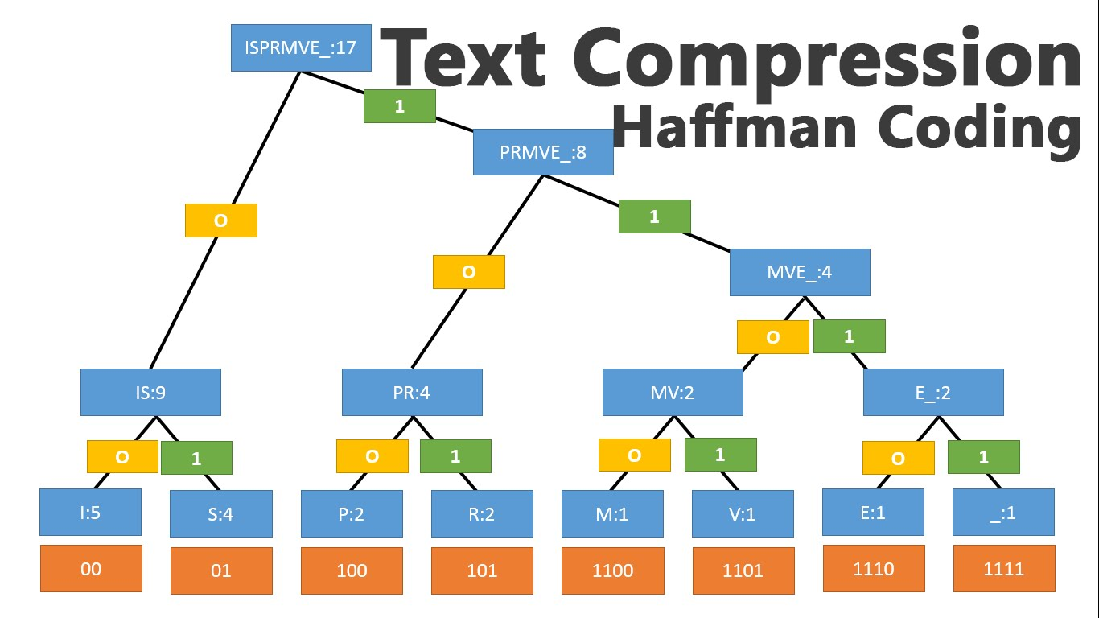

**HUFFMAN CODING**

**SOURCE CODE**

#include <iostream>

#include <cmath>

using namespace std;

struct node

{

char info;

int freq;

char *code;

node *Llink;

node *Rlink;

};

class BinaryTree // Coding Tree

{

private:

node *root;

public:

BinaryTree() { root=NULL; }

void print();

// Symbols with their frequencies are stored in the leaf nodes.

// The path from the root to the leaf node is the code of the symbol

// By convention, '0' is for left sub-tree and '1' for right sub-tree.

void assign_code(int i);

void print_code(char c);

void encode(const char str[]);

void print_symbol(char cd[], int &f, int length);

void decode(char cd[], int size);

friend class minHeap;

friend class HuffmanCode;

};

class minHeap

{

private:

BinaryTree *T; // Array of Binary Trees

int n;// Number of symbols

public:

minHeap();

void heapify(int i);

BinaryTree remove(); // Returns the first Binary Tree of the min heap and then

// heapify the array of Binary trees in order of the frequencies of their root nodes.

void insert(BinaryTree b);// To insert another Binary tree

// and then heapify the array of Binary trees

void print(); // To print the frequencies of the root nodes of the array of Binary Trees

friend class HuffmanCode; // It can access the private data i.e. the array of Binary Trees

};

class HuffmanCode

{

private:

BinaryTree HuffmanTree;//A Huffman Tree (a minimum weighted external path length tree) //with symbols as external nodes.

public:

HuffmanCode();

};

HuffmanCode::HuffmanCode()

{

minHeap Heap;

// Huffman Tree is build from bottom to top.

// The symbols with lowest frequency are at the bottom of the tree

// that leads to longer codes for lower frequency symbols and hence

// shorter codes for higher frequency symbol giving OPTIMAL codelength.

while (Heap.T[0].root->freq>1)

{

// The first two trees with min. priority (i.e. frequency) are taken and

BinaryTree l=Heap.remove();

cout<<"\nAfter removing "<<l.root->freq<<endl;

Heap.print();

BinaryTree r=Heap.remove();

cout<<"\nAfter removing "<<r.root->freq<<endl;

Heap.print();

// a new tree is constructed taking the above trees as left and right sub-trees

// with the frequency of root node as the sum of frequencies of left and right child.

HuffmanTree.root=new node;

HuffmanTree.root->info='\0';

HuffmanTree.root->freq=l.root->freq + r.root->freq;

HuffmanTree.root->Llink=l.root;

HuffmanTree.root->Rlink=r.root;

// then it is inserted in the array and array is heapified again.

// Deletion and Insertion at an intermediate step is facilitated in heap-sort.

Heap.insert(HuffmanTree);

cout<<"\nAfter inserting "<<l.root->freq<<"+"<<r.root->freq<<"= "<<HuffmanTree.root->freq<<endl;

Heap.print();

}

//The process continues till only one tree is left in the array of heap.

cout<<"\nThe process is completed and Huffman Tree is obtained\n";

system ("pause");

HuffmanTree=Heap.T[1];// This tree is our HuffmanTree used for coding

delete []Heap.T;

cout<<"Traversal of Huffman Tree\n\n";

HuffmanTree.print();

system ("pause");

cout<<"\nThe symbols with their codes are as follows\n";

HuffmanTree.assign_code(0);

system ("pause"); // Codes are assigned to the symbols

cout<<"Enter the string to be encoded by Huffman Coding: ";

char *str;

str=new char[50];

cin>>str;

HuffmanTree.encode(str);

system ("pause");

int length;

cout<<"Enter the code to be decoded by Huffman Coding: ";

char *cd;

cd=new char[60];

cin>>cd;

cout<<"Enter its code length: ";

cin>>length;

HuffmanTree.decode(cd,length);

system ("pause");

}

minHeap::minHeap()

{

cout<<"Enter no. of symbols:";

cin>>n;

T= new BinaryTree [n+1];

T[0].root=new node;

T[0].root->freq=n; //Number of elements in min. Heap is stored in the zeroth element of the heap

for (int i=1; i<=n; i++)

{

T[i].root=new node;

cout<<"Enter characters of string :- ";

cin>>T[i].root->info;

cout<<"and their frequency of occurence in the string:- ";

cin>>T[i].root->freq;

T[i].root->code=NULL;

T[i].root->Llink=NULL;

T[i].root->Rlink=NULL;

// Initially, all the nodes are leaf nodes and stored as an array of trees.

}

cout<<endl;

int i=(int)(n / 2); // Heapification will be started from the PARENT element of //the last ( 'n th' ) element in the heap.

cout<<"\nAs elements are entered\n";

print();

while (i>0)

{

heapify(i);

i--;

}

cout<<"\nAfter heapification \n";

print();

}

int min(node *a, node *b)

{

if (a->freq <= b->freq) return a->freq;

else return b->freq;}

void swap(BinaryTree &a, BinaryTree &b)

{ BinaryTree c=a; a=b; b=c; }

void minHeap::heapify(int i)

{

while(1)

{

if (2*i > T[0].root->freq)

return;

if (2*i+1 > T[0].root->freq)

{

if (T[2*i].root->freq <= T[i].root->freq)

swap(T[2*i],T[i]);

return;

}

int m=min(T[2*i].root,T[2*i+1].root);

if (T[i].root->freq <= m)

return;

if (T[2*i].root->freq <= T[2*i+1].root->freq)

{

swap(T[2*i],T[i]);

i=2*i;

}

else

{

swap(T[2*i+1],T[i]);

i=2*i+1;

}

}

}

BinaryTree minHeap::remove()

{

BinaryTree b=T[1];

T[1]= T[T[0].root->freq];

T[0].root->freq--;

if (T[0].root->freq!=1)

heapify(1);

return b;

}

void minHeap::insert(BinaryTree b)

{

T[0].root->freq++;

T[T[0].root->freq]=b;

int i=(int) (T[0].root->freq /2 );

while (i>0)

{

heapify (i);

i=(int) (i /2 );

}

}

int isleaf(node *nd)

{ if(nd->info=='\0') return 0; else return 1; }

void BinaryTree::assign_code(int i)

{

if (root==NULL)

return;

if (isleaf(root))

{

root->code[i]='\0';

cout<<root->info<<"\t"<<root->code<<"\n";

return;

}

BinaryTree l,r;

l.root=root->Llink;

r.root=root->Rlink;

l.root->code=new char[i+1];

r.root->code=new char[i+1];

for (int k=0; k<i; k++)

{

l.root->code[k]=root->code[k];

r.root->code[k]=root->code[k];

}

l.root->code[i]='0';

r.root->code[i]='1';

i++;

l.assign_code(i);

r.assign_code(i);

}

void BinaryTree::encode(const char str[])

{

if (root==NULL)

return;

int i=0;

cout<<"Encoded code for the input string '"<<str<<"' is\n";

while (1)

{

if (str[i]=='\0')

{

cout<<endl;

return;

}

print_code(str[i]);

i++;

}

}

void BinaryTree::print_code(char c)

{

int f=0;

if (isleaf(root))

{

if (c==root->info)

{

f=1;

cout<<root->code;

}

return ;

}

BinaryTree l,r;

l.root=root->Llink;

if (f!=1)

l.print_code(c);

r.root=root->Rlink;

if (f!=1)

r.print_code(c);

}

int isequal(const char a[], const char b[], int length)

{

int i=0;

while (i<length)

{

if(b[i]!=a[i])

return 0;

i++;

}

if (a[i]!='\0')

return 0;

return 1;

}

void BinaryTree::decode(char cd[], int size)

{

if (root==NULL)

return;

int i=0;

int length=0;

int f;

char *s;

cout<<"Decoded string for the input code '"<<cd<<"' is\n";

while (i<size)

{

f=0;

s=&cd[i];

while (f==0)

{

length++;

print_symbol(s,f,length);

}

i=i+length;

length=0;

}

cout<<endl;

}

void BinaryTree::print_symbol(char cd[], int &f, int length)

{

if (isleaf(root))

{

if (isequal(root->code, cd, length))

{

f=1;

cout<<root->info;

}

return;

}

BinaryTree l,r;

l.root=root->Llink;

if (f!=1)

l.print_symbol(cd,f,length);

r.root=root->Rlink;

if (f!=1)

r.print_symbol(cd,f,length);

}

void BinaryTree::print()

{

if (root==NULL)

return;

cout<<root->info<<"\t"<<root->freq<<"\n";

if (isleaf(root))

return;

BinaryTree l,r;

l.root=root->Llink;

r.root=root->Rlink;

l.print();

r.print();

}

int power(int i, int j)

{

int n=1;

for (int k=1; k<=j; k++)

n=n*i;

return n;

}

int ispowerof2(int i)

{

if (i==1)

return 0;

if (i==0)

return 1;

while (i>2)

{

if (i%2!=0)

return 0;

i=i/2;

}

return 1;

}

int fn(int l)

{

if (l==1||l==0)

return 0;

return 2*fn(l-1)+1;

}

void minHeap::print()

{

cout<<"The Heap showing the root frequencies of the Binary Trees are:\n";

if (T[0].root->freq==0)

{

cout<<endl;

system ("pause");

return;

}

int level=1;

while( T[0].root->freq >= power(2,level) )// 2^n-1 is the max. no. of nodes

///in a complete tree of n levels

level++;

if(level==1)

{

cout<<T[1].root->freq<<"\n";

system ("pause");

return;

}

for (int i=1; i<=T[0].root->freq; i++)

{

if (ispowerof2(i))

{cout<<"\n"; level--;}

for (int k=1; k<=fn(level); k++)

cout<<" ";

cout<<T[i].root->freq<<" ";

for (int k=1; k<=fn(level); k++)

cout<<" ";

}

cout<<endl;

system ("pause");

}

int main()

{

HuffmanCode c;

system ("pause");

return 0;

}

**OUTPUT**

**1.** 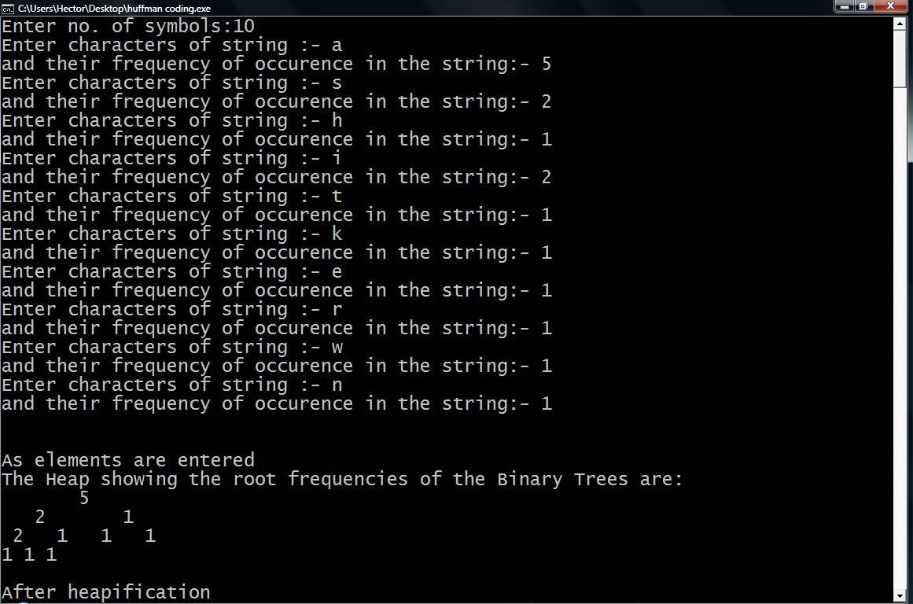

**2.**

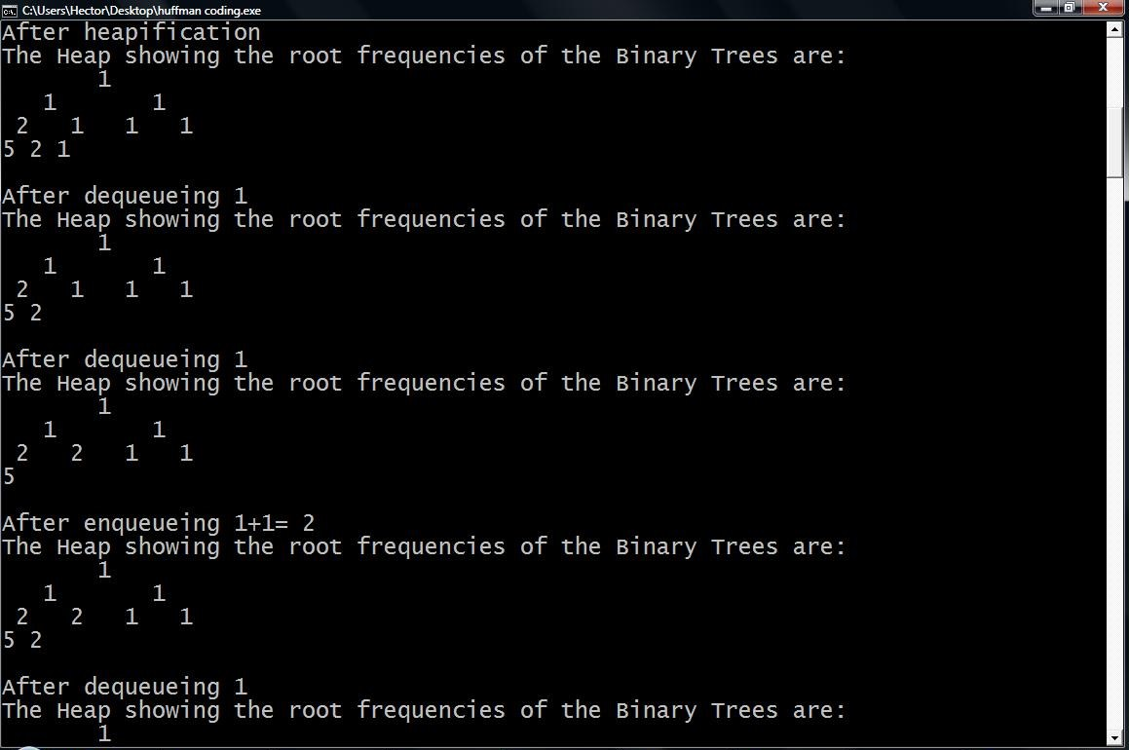

**3.**

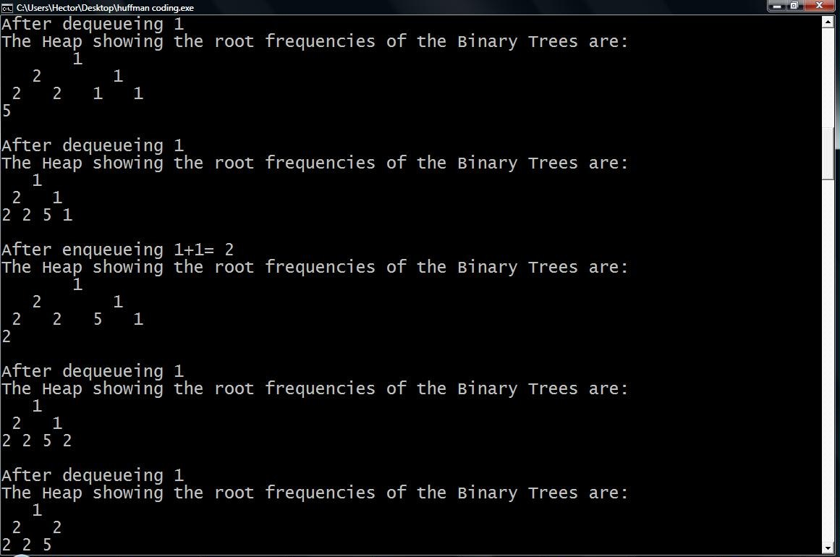

**4.**

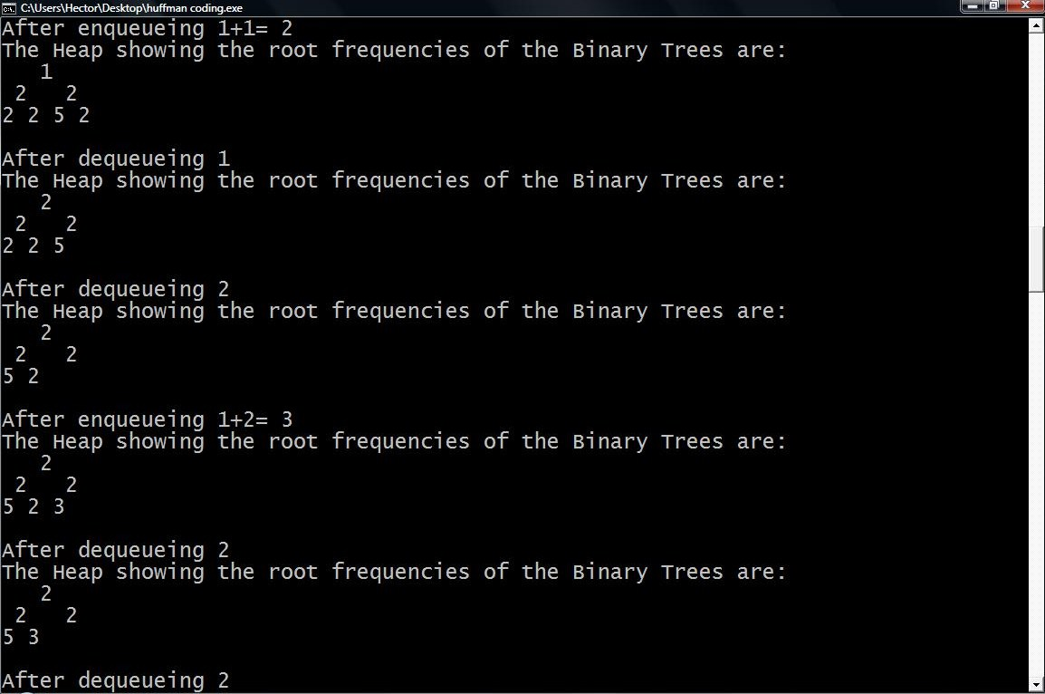

**5.**

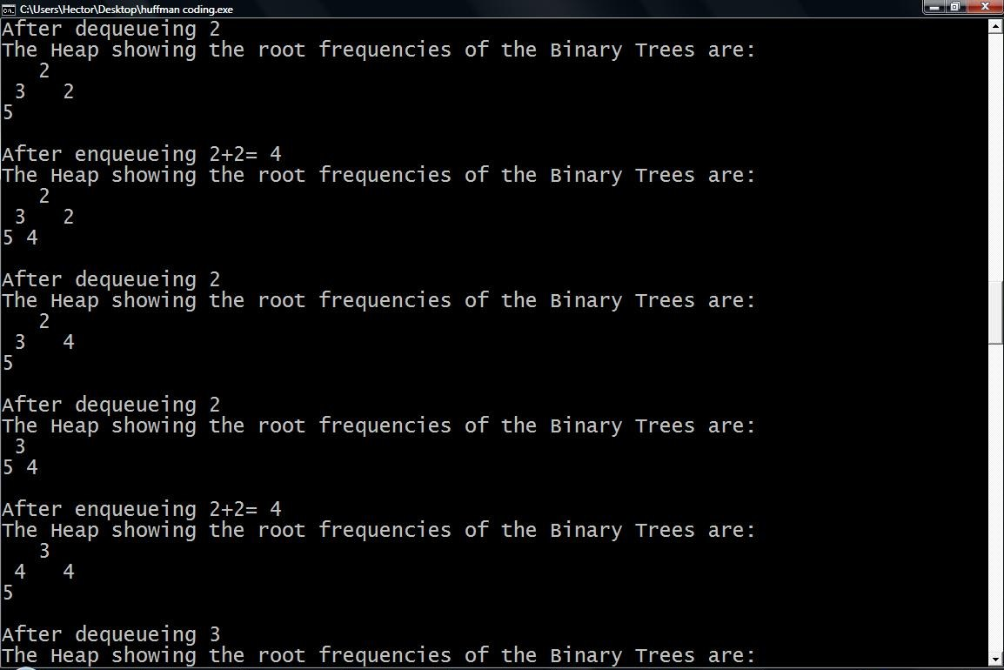

**6.**

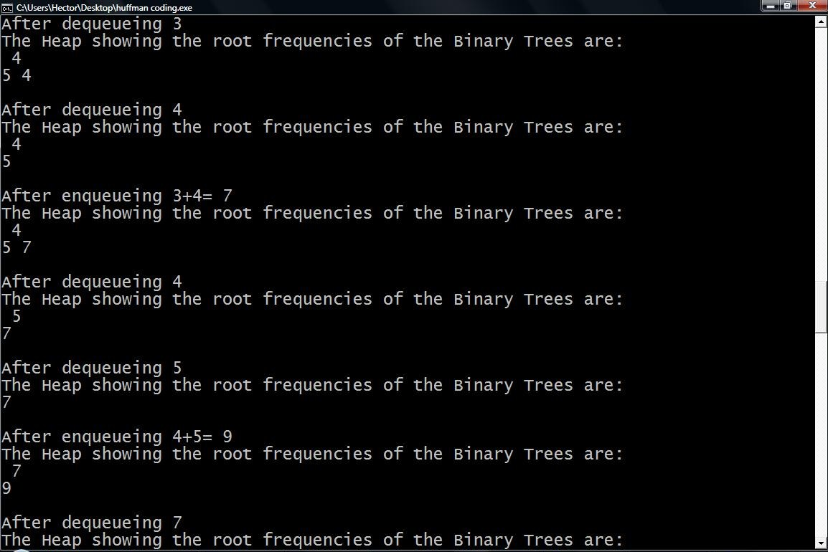

**7.**

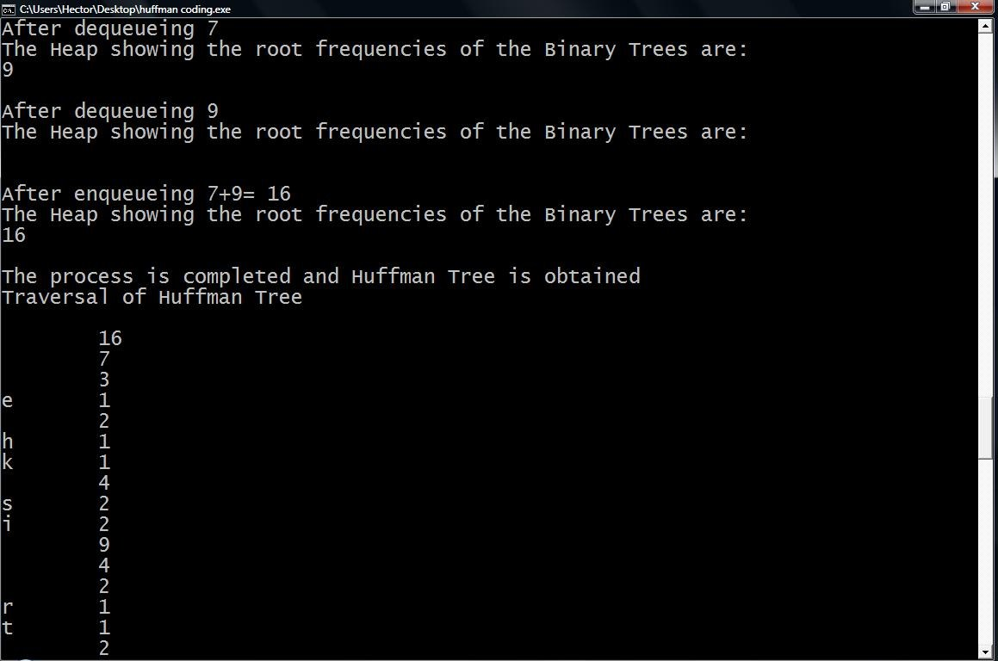

**8.**

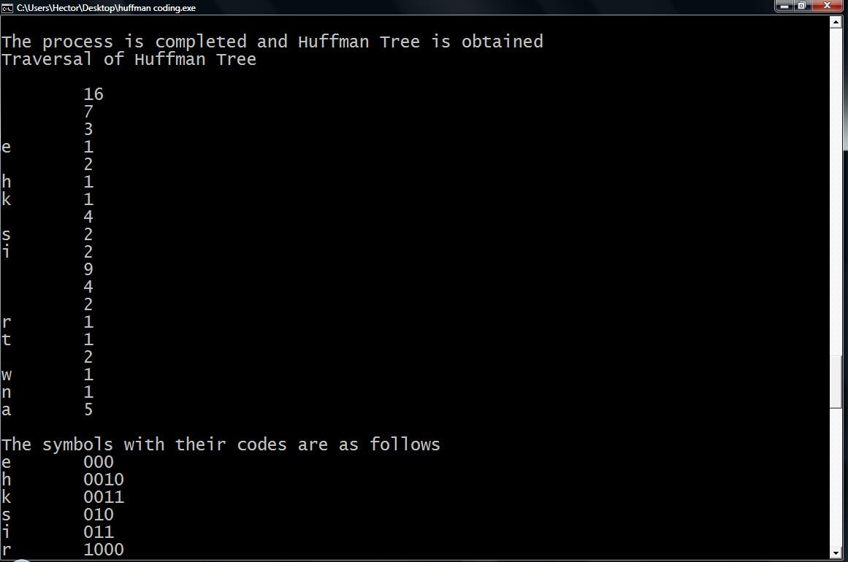

**9.**

